Desk Number ________

Student Number _______________________

Student Name _______________________

**School of Science and Engineering**

**FINAL EXAMINATION**

Semester 1, 2018

**CSC1001 Introduction to Computer Science**

Examination Duration: 120 minutes

Reading Time: 10 minutes

This examination has __3__ questions.

**Exam Conditions:**

This is a FORMAL Examination

This is a RESTRICTED OPEN BOOK Exam. Maximum of one (1) sheet of handwritten notes double sided are permitted

**Materials Permitted In The Exam Venue:**

Maximum of one (1) sheet of handwritten notes double sided are permitted. **NO OTHER MATERIALS PERMITTED**

Any calculators without the functionalities of programming and file storage are permitted.

**Materials To Be Supplied To Students:**

1 × 12 Page Answer Booklet

Question 1. (15 × 2% = 30%)

Pick the correct option in each of the following sub-questions. Note that only ONE option is correct.

1. Convert the hexadecimal number 10.01 to the binary number, the answer is:
2. 10000.00000001
3. 10.01
4. 1000.00000001
5. 10000.0000001
6. What is the output of the following statement?



1. Ab Cd Ef
2. aB CD EF
3. aB cD eF
4. None of the mentioned
5. What is the output of the following code?

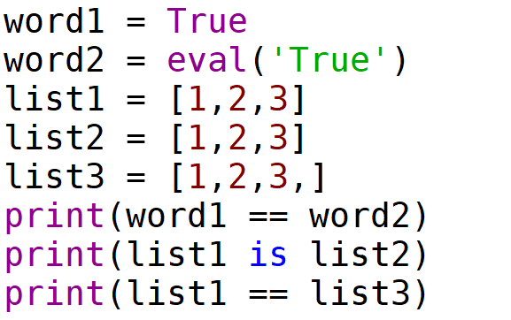

A.

True

False

True

B.

False

False

True

C.

True

True

False

D.

False

True

False

1. What is the possible output of the code shown below?

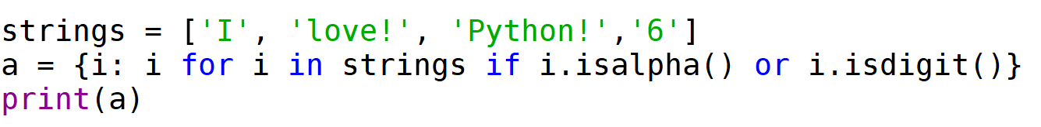

A. { '6': '6'}

B. { 'I': 'I', 'love!': 'love!', 'Python!': 'Python!', '6': '6'}

C. { 'I': 'I', 'love!': 'love!', '6': '6'}

D. { 'I': 'I', '6': '6'}

1. What is the output of the following code?

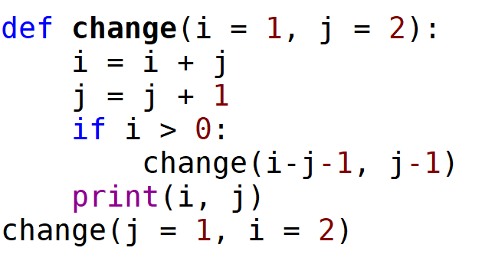

A.

-1 2

1 2

3 2

B.

3 2

1 2

-1 2

C.

1 2

0 1

-1 -1

D. It will trigger an error.

1. What is the output of the following code?

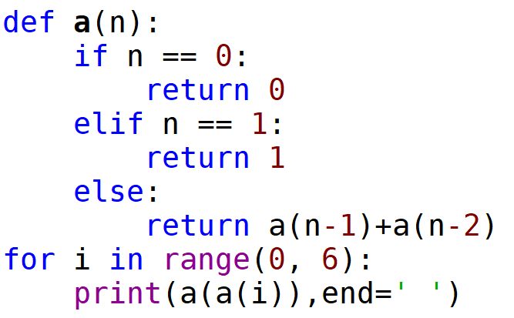

A. 1 1 1 1 1 0

B. 0 1 1 1 1 1

C. 0 1 1 1 2 5

D. It is an infinite loop.

1. What is the output of the following piece of code?

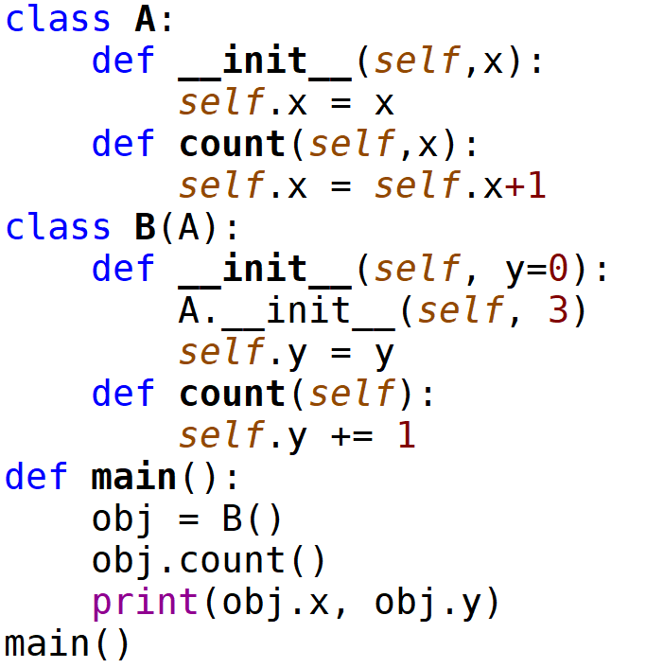

A. 1 4

B. 3 1

C. 4 1

D. It will trigger an error.

1. Concerning the following program, which of the following statements is incorrect?

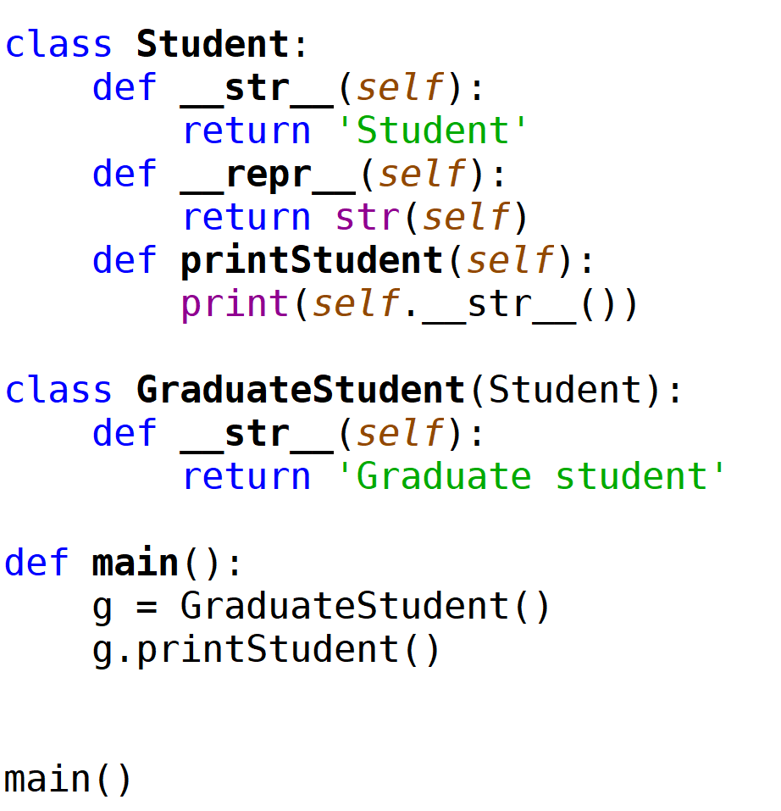

1. The output of this program is ‘Student’.
2. In class GraduateStudent(), method __repr__() will be inherited from class Student().
3. Method __str__() has been overridden in class GraduateStudent().
4. In class GraduateStudent(), method printStudent() will be inherited from class Student().
5. What is the output of the following code?

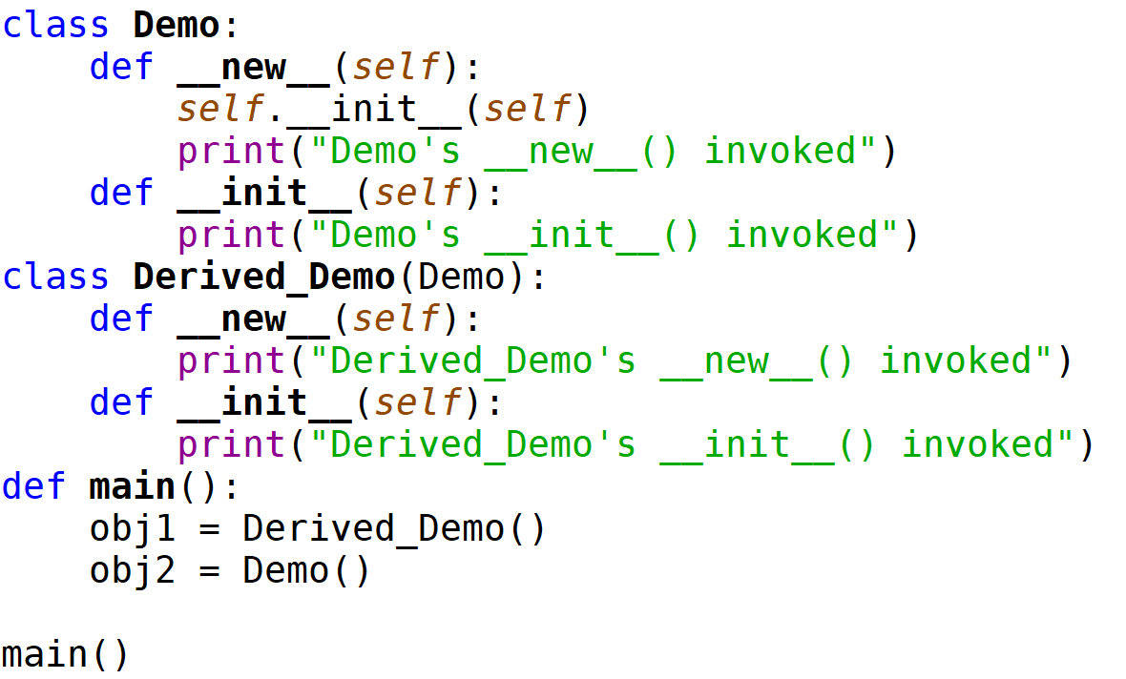

A.

Derived_Demo’s __init__() invoked

Derived_Demo’s __new__() invoked

Demo’s __init__() invoked

Demo’s __new__() invoked

B.

Derived_Demo’s __new__() invoked

Demo’s __init__() invoked

Demo’s __new__() invoked

C.

Derived_Demo’s __new__() invoked

Demo’s __new__() invoked

D.

Derived_Demo’s __init__() invoked

Demo’s __init__() invoked

1. Suppose you have the following sorted list [3, 5, 6, 8, 11, 12, 14, 15, 17, 18] and are using the recursive binary search algorithm. Which group of numbers correctly shows the sequence of comparisons used to find the key 8.

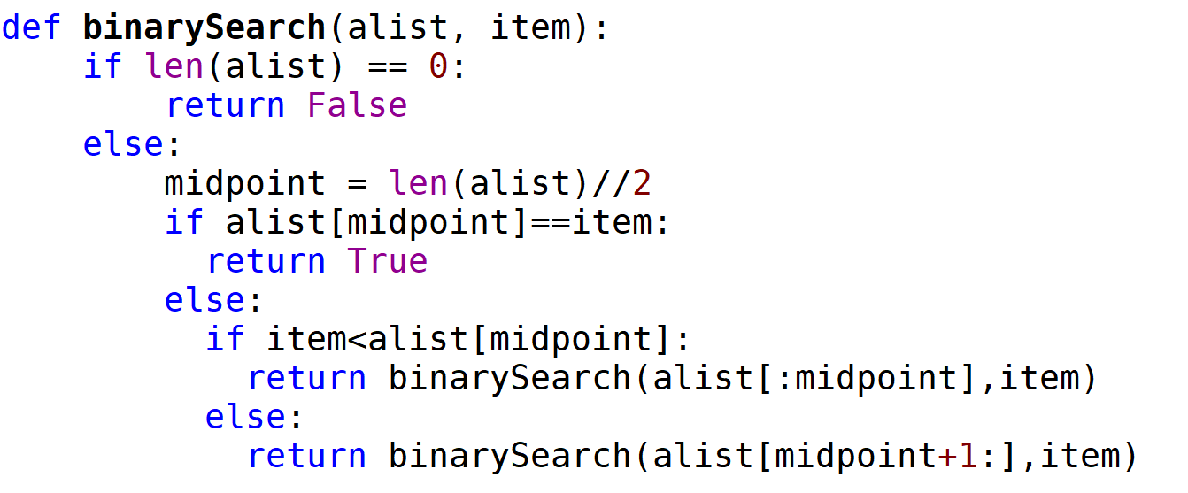

1. 11, 5, 6, 8
2. 12, 6, 11, 8
3. 3, 5, 6, 8
4. 18, 12, 6, 8
5. The height of a binary tree is the maximum number of edges in any root to leaf path. The maximum number of nodes in a binary tree of depth $d$ is:

A. $2^{d}-1$

B. $2^{d-1}-1$

C. $2^{d+1}-1$

D. $2*(d-1)$

1. A person wants to visit some places. He starts from a vertex and then wants to visit every vertex till it finishes from one vertex, backtracks and then explore other vertex from same vertex. What algorithm he should use?
2. Depth First Search
3. Breadth First Search
4. Quick sort
5. None of the mentioned
6. What is time complexity of fun(n)?

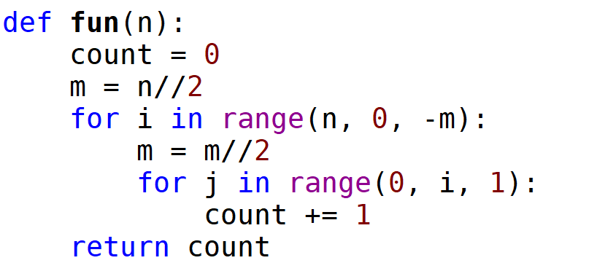

14) Concerning class in Python, which of the following statement is correct?

A. A class may not have a super class.

B. Dynamic binding is a mechanism concerning how to initialize data fields.

C. Private methods can be overridden.

D. Polymorphism means the objects of different classes cannot be passed as arguments to the same function.

15) Concerning object and class, which of the following statement is incorrect?

1. The id of an object is automatically assigned by Python.
2. An object is a special example of the corresponding class.
3. If __init__() method is not defined in a class, it will not be called automatically.
4. Class abstraction means you do not have to read the code of a class before you can use it.

Question 2. (10 × 4% = 40%)

Pick the correct option/s in each of the following sub-questions. Note that there may be MULTIPLE correct options for each sub-question. If your answer is partially correct, you will get 2 points.

1. Which of the following statement(s) is/are correct?
2. A public method in a superclass can be overridden.
3. A subclass contains more information than its superclass.
4. The value of a private data field in the superclass can be changed in the subclass.
5. When invoking the initializer from a subclass, the initializer of superclass is automatically invoked.
6. Concerning algorithm analysis, which of the following statement(s) are/is incorrect?
7. In algorithm analysis, we usually focus on the worst-case input.
8. In algorithm analysis, the size of the problem is irrelevant to the performance of an algorithm.
9. In algorithm analysis, running time is the only measure of the goodness of an algorithm.
10. In algorithm analysis, experimental analysis is preferred since it can accurately measure the exact running time of an algorithm.
11. Concerning an algorithm, which of the following statement(s) are/is correct?
12. Big Oh notation can be used to represent the average performance of an algorithm.
13. Big Oh notation can be used to represent the worst-case performance of an algorithm.
14. An exponential time algorithm is acceptable in practice.
15. An algorithm with a time complexity of $O(logn)$ is always better than an algorithm with a time complexity of $O(n^{2})$.
16. Concerning recursion, which of the following statement(s) are/is incorrect?
17. Recursion is a programming technique by which a function makes a call to itself.
18. Recursion can be used to solve repetitive task.
19. A recursive definition of a problem will contain both recursive and non-recursive cases.
20. Binary search and depth first search can both be implemented based on recursion.

20) Concerning the following program, which of the following statement(s) are/is correct?

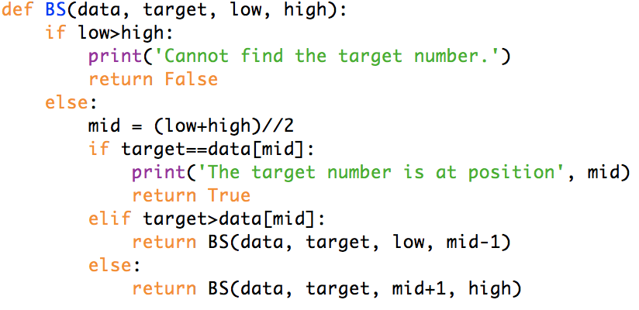

1. This function can be used to search a target number in any sequence.
2. This function can be used to search a target number in a sequence with ascending order.
3. The time complexity of this algorithm is $O(logn)$.
4. The time complexity of this algorithm is .

21) Concerning stack, which of the following statement(s) are/is incorrect?

1. Stack is a data structure which saves and removes data following the “first-in-last-out” principle.
2. Stack is a data structure which saves and removes data following the “last-in-last-out” principle.
3. The time complexity of inserting data at the top of a stack is constant.
4. The time complexity of removing data at the top of a stack is linear.
5. Concerning singly linked list, which of the following statement(s) are/is correct?
6. A node of a singly linked list usually consists of two data fields.
7. A singly linked list object usually contains two data fields, which are two references pointing to the head and tail of the list.
8. The time complexity of removing the head node of a singly linked list is constant.
9. The time complexity of removing the tail node of a singly linked list is constant.
10. Concerning tree, which of the following statement(s) are/is correct?
11. Each element in a tree has a parent element and zero or more children elements.
12. Tree is a data structure which saves data in a hierarchical way.
13. An edge of a tree is a pair of arbitrary nodes.
14. A node on a binary tree has either zero or two children.

24) Concerning circularly linked list, which of the following statement(s) are/is correct?

1. A circularly linked list object usually contains two reference data fields.
2. The time complexity of inserting at the head of the circularly linked list is constant.
3. The time complexity of removing a node from the tail of the circularly linked list is constant.

D. Circularly linked list can be used to fairly allocate shared resources.

25) Concerning a binary tree, which of the following statement(s) are/is correct?

1. To search a binary tree, a recursive algorithm can be used.
2. A binary tree may be an unordered tree.
3. The number of nodes on a full binary tree is an odd number.
4. The principle of breadth first search is to visit the high-level nodes first.

Question 3. (4% + 4% + 7% + 7% + 8% = 30%)

Answer the following questions.

* 1. Concerning the following program:

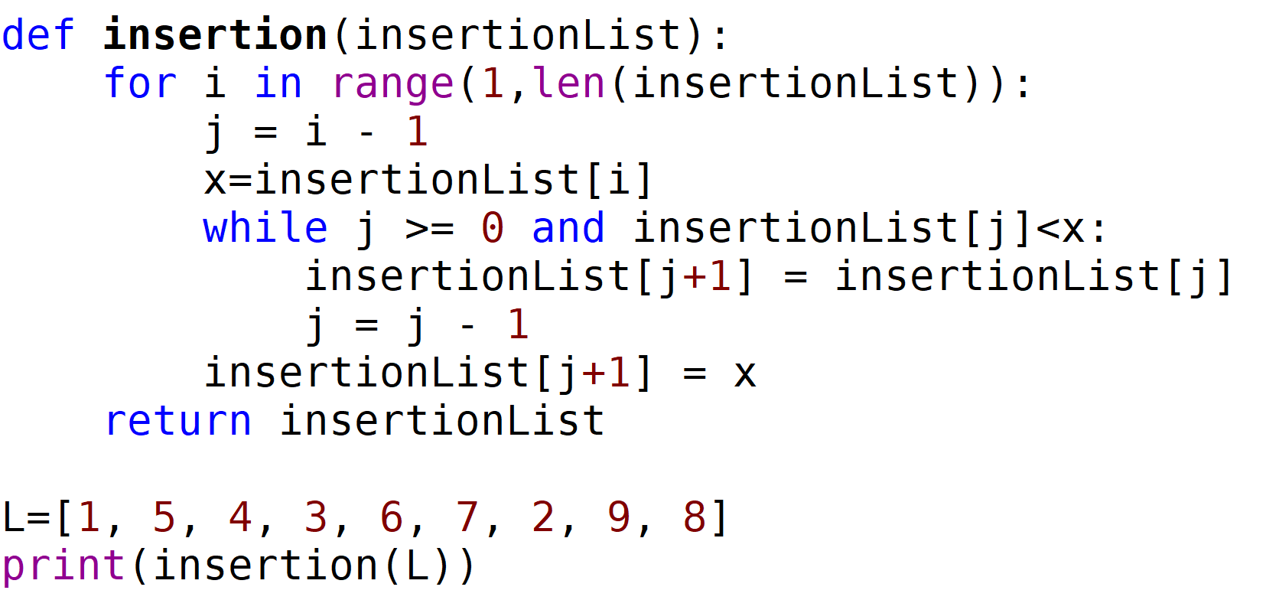

Answer the following questions:

1. What is the output of this program?
2. What is the time complexity of this sorting algorithm?
   1. Concerning the following program:

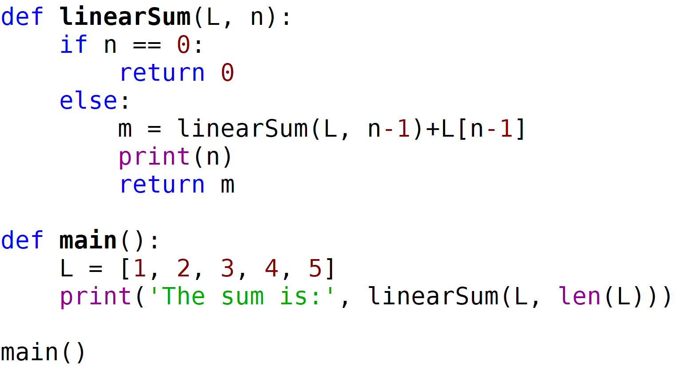

Answer the following questions:

1. How many times function linearSum() will be called in total?
2. What are the outputs of this program?
   1. Write a function which takes two inputs n and m, and outputs n*m. This function should be a recursive function and have a time complexity of O(log n).
   2. Concerning the following program, the upper part is to implement a stack with a singly linked list, the lower part is to reverse the order of a list of numbers using the stack class.
3. Please fill the blank in the code. Notice that in one blank location only one line of code should be filled. Please put your answer in your answer book.

B. What is the output of this program?

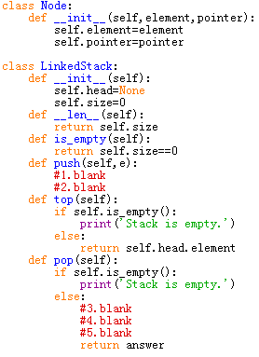

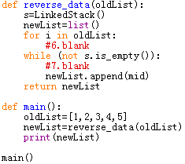

* 1. Concerning the following program, and assume that input t will be a reference pointing to the root of a binary tree. Notice that the ListQueue() class is the queue class.

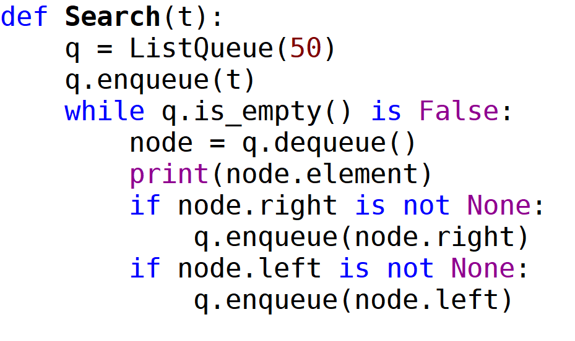

Answer the following questions:

1. Which algorithm is implemented in this function?
2. What is the time complexity of this algorithm?
3. Is this function a linear recursive or multiple recursive function?
4. If input t is referencing to the root of the following tree, what would be the outputs of this function?

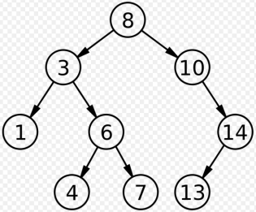

**END OF EXAMINATION**